TASK 1: TABLE WITHOUT TIME

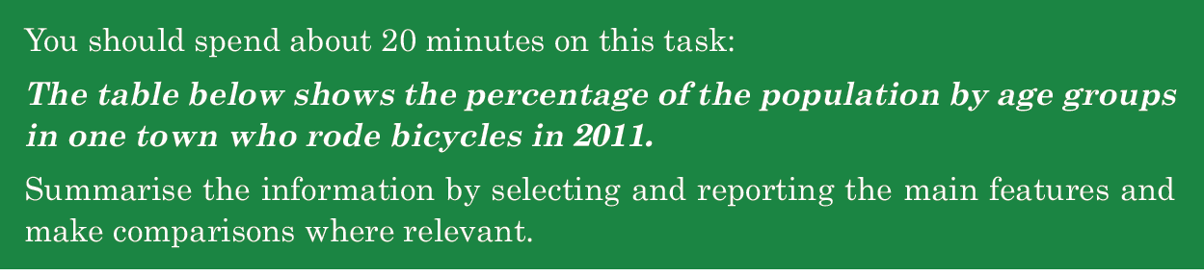

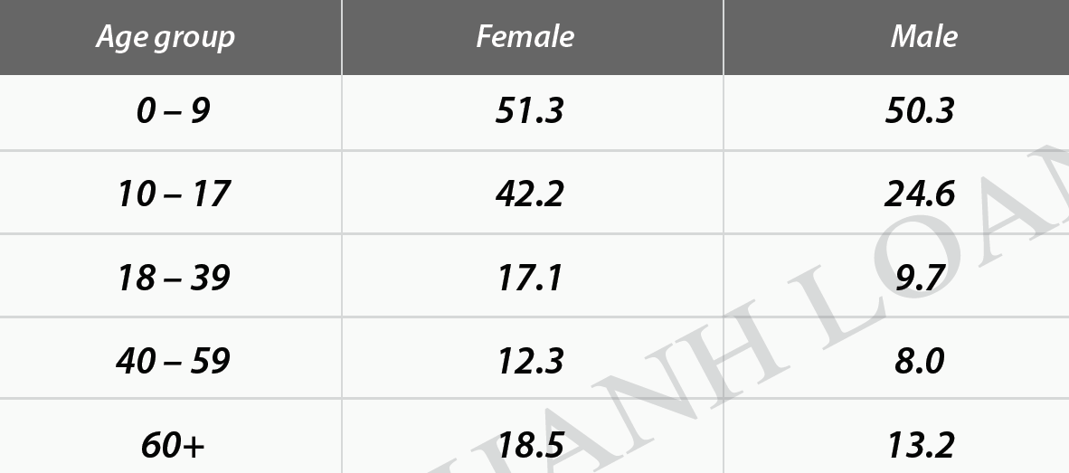
SAMPLE
The table provides data regarding the proportions of people in various age brackets of a town who pedaled in 2011.
Overall, the youngest age group (0-9) took the lion’s share in the number of people enjoying riding a bike, whereas the reversal was true for the age group 40-59. Additionally, the percentage of females who cycled every day exceeded that of males over the same period.
As the chart reveals, among five groups, under 9-year-old cyclists accounted for the largest proportion that year, with the figure for females outnumbering that of males, at 51.3% and 50.3% respectively. The disparity between the two genders was broadened when it comes to the 10-17 age group, with 42.2% of females and 24.6% of males. However, as for the older age (18-39), both genders’ figures commuting by bike declined significantly, amounting to approximately a third of the 10-17 group’s figures.
In term of the two oldest groups, 12.3% of females in their 40s and 50s used bike, 4.3% higher than the figure for their male counterparts. In contrast, the popularity of pedaling increased when people reached 60+, but this mode of transport was still more widely-used among females than males, occupying 18.5% and 13.2% consecutively.
199

Outnumber/ surpass/ overshadow /overtake

Respectively
In turn
Consecutively
orderly

Disparity=difference

Về mặt , đề cập đến
As for
In term of
Concerning
Relating to
Regarding
When it comes to

In contrast,
However,
Meanwhile.
-----while, whereas, whilst-------
Conversely,
On the other hand,

Regarding the other three age groups from 18 to over 60, the female figures always outnumbered those of male, altering from 12.3 to 18.5 for female, and between 8.0 and 13.2 for male.

Vary / alter/ oscillate from----to dao động trong khoảng
between ----and

======================

TASK 1: TABLE PRACTICE

You should spend about 20 minutes on this task.
The graph below shows the percentage of unemployed people aged between 15 and 24 in five European countries in 2005, compared with the overall percentage of unemployment in those countries.
Summarize the information by selecting and reporting the main features and make comparisons where relevant.
Write at least 150 words.
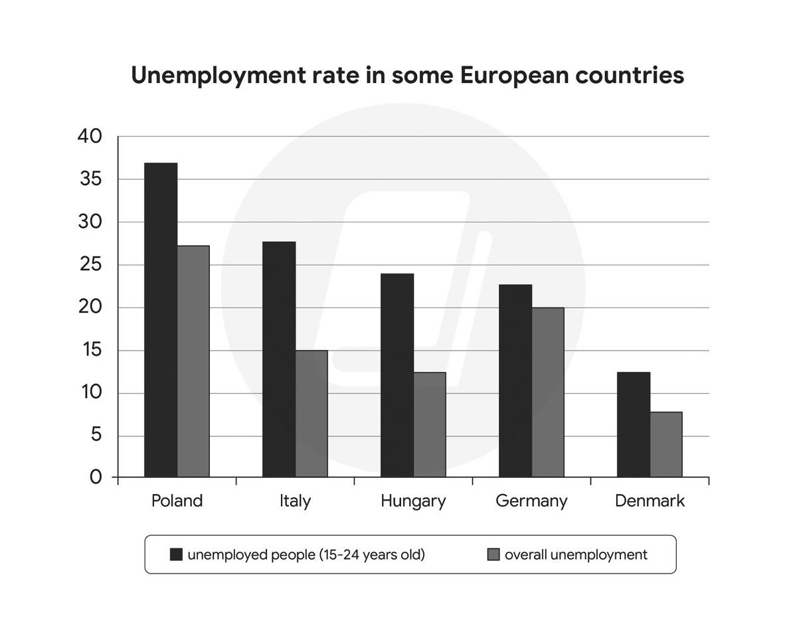

The chart supplies data regarding the percentage of jobless people aged from 15 to 24 in five European countries in 2005, comparing duoc so sanh voi / compared with the overall percentage of unemployment in those countries.
overall, the percentage of unwaged people aging from 15 to 24 in Poland took the lion' share in all countries Poland chiem muc cao nhat trong ti le nguoi that nghiep cua nguoi tu 15-24 trong tat ca cac nuoc / Poland took the lion’ share in the percentage of unwaged people aging from 15 to 24 in all countries , whilst trong khi do Denmark chiem ti le nho nhat trong nhung con so nay / whilst Denmark held a rather minuscule part in these numbers . Tuong tu, ca former va latter deu dung top va bottom tren danh sach cua overall unemployment theo thu tu da neu / similarly, both the former and the latter reached the top and the bottom on the list of overall jobless people respectively . this number of Denmark held a rather minuscule part of the others. Additionally, the percentage of overall jobness humans in Poland and Denmark reach the top for the former and hit a trough for the latter .
As the chart reveals, the proportion of unemployed people aging between 15 and 24 in Poland surpassed that of / those of the others, reaching averagely 36 % . Nguoc lai, Denmark’s figure/ that of---- / By contrast, Denmark’s figure ( tranhs dung this ) This number of Denmark exhibited a trough of, chi gan---- nearly 13% in all countries ( nearly 13% ) .Meanwhile, These / the ( khong dung this these ) figures in Italy, Hungary and Germany ranged from around 24% to approximately 28% .
As for ti le that nghiep noi chung / the general unemployment rate the percentage of overall idle citizens , this quantity in trong khi Poland dan dau (led at) hit a peak at relatively 26% / while Poland led at relatively 26%, two - third that of the unemployed 15-24-year-old humans aging from 15 to 24 , con so do cua DM chiem muc thap nhat (most insignificant ) / that of Danmark accounted for the most insignificant section, only comperatively 6% ( thap nhat len dung only ) Similarly, the Denmark number bottom out at comparatively 6% . Cac nuoc con lai gom Hung, Ita va Ger dao dong tu
Khoang 13-20 voi Ger co ti le that nghiep cao nhat among them / the remanding countries icluding Itanly , Hungary and Germany altered ranged between 13% and 20% with Germany registering a maximum unemployum rate among them .

The figures in Itanly and Hungary altered from 13% to 15 % . In addition , the number of Germany amounted to 20% , two-fifths that of unemployment ( 15 - 24 years old ) .
220 words

BAND SCORE: 4.0

The chart supplies data regarding the percentage of jobless people aged from 15 to 24 in five European countries in 2005, comparing duoc so sanh voi / compared with the overall percentage of unemployment in those countries.
overall, the percentage of unwaged people aging from 15 to 24 in Poland took the lion' share in all countries Poland chiem muc cao nhat trong ti le nguoi that nghiep cua nguoi tu 15-24 trong tat ca cac nuoc / Poland took the lion’ share in the percentage of unwaged people aging from 15 to 24 in all countries , whilst trong khi do Denmark chiem ti le nho nhat trong nhung con so nay / whilst Denmark held a rather minuscule part in these numbers . Tuong tu, ca former va latter deu dung top va bottom tren danh sach cua overall unemployment theo thu tu da neu / similarly, both the former and the latter reached the top and the bottom on the list of overall jobless people respectively . this number of Denmark held a rather minuscule part of the others. Additionally, the percentage of overall jobness humans in Poland and Denmark reach the top for the former and hit a trough for the latter .
As the chart reveals, the proportion of unemployed people aging between 15 and 24 in Poland surpassed that of / those of the others, reaching averagely 36 % . Nguoc lai, Denmark’s figure/ that of---- / By contrast, Denmark’s figure ( tranhs dung this ) This number of Denmark exhibited a trough of, chi gan---- nearly 13% in all countries ( nearly 13% ) .Meanwhile, These / the ( khong dung this these ) figures in Italy, Hungary and Germany ranged from around 24% to approximately 28% .
As for ti le that nghiep noi chung / the general unemployment rate the percentage of overall idle citizens , this quantity in trong khi Poland dan dau (led at) hit a peak at relatively 26% / while Poland led at relatively 26%, two - third that of the unemployed 15-24-year-old humans aging from 15 to 24 , con so do cua DM chiem muc thap nhat (most insignificant ) / that of Danmark accounted for the most insignificant section, only comperatively 6% ( thap nhat len dung only ) Similarly, the Denmark number bottom out at comparatively 6% . Cac nuoc con lai gom Hung, Ita va Ger dao dong tu
Khoang 13-20 voi Ger co ti le that nghiep cao nhat among them / the remanding countries icluding Itanly , Hungary and Germany altered ranged between 13% and 20% with Germany registering a maximum unemployum rate among them .

